First we go to the Project structure in ( file -> Project structure ) open Libraries and from here we click on the ( + ) button and we add the libraries ONE by ONE.

It should look like this.

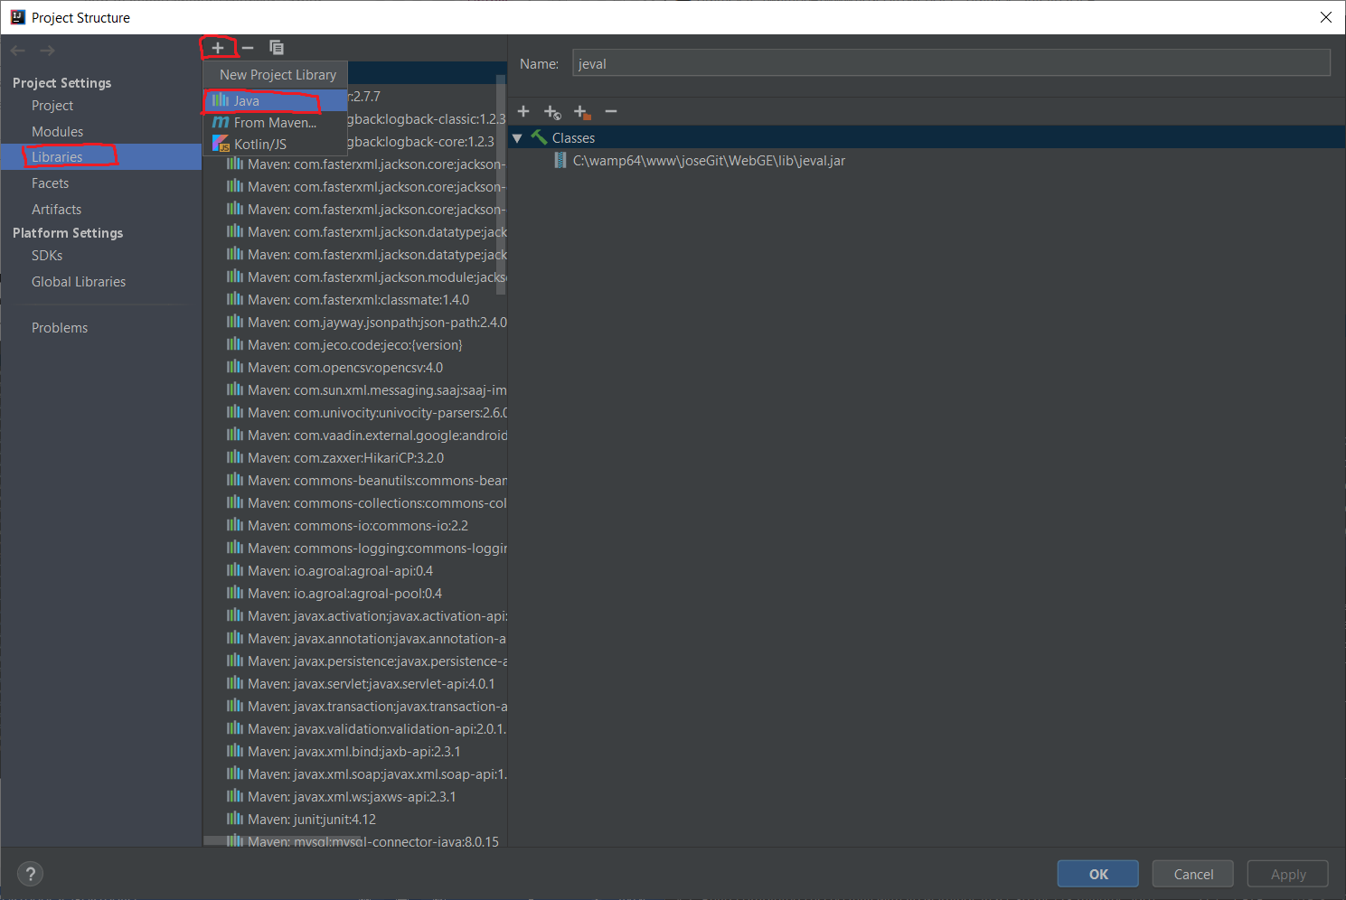

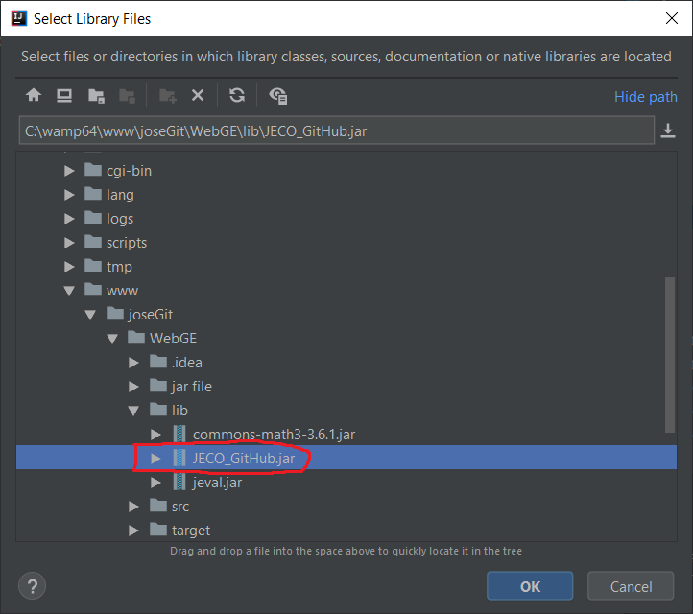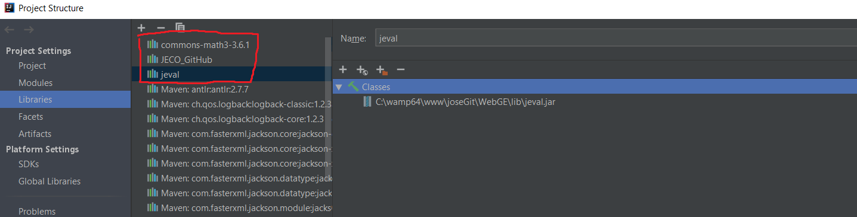

To add the JECO dependency you need to intall it, just execute this code in maven:

**install:install-file -Dfile=C:\wamp64\www\WebGEx\lib\JECO_GitHub.jar -DgroupId=com.jeco.code -DartifactId=jeco -Dversion={version} -Dpackaging=jar**

**- Dont Forget to change the location of your JECO_GitHub.jar.**

